**n8n Data Analyst AI Agent Workflow Documentation**

**Overview**

This workflow creates an intelligent data analyst chatbot that queries cricket batsmen statistics from a MySQL database, uses Google Gemini AI to analyze the data, and sends the results via Telegram. The workflow provides an interactive chat interface where users can ask questions about cricket statistics.

**Workflow Architecture**

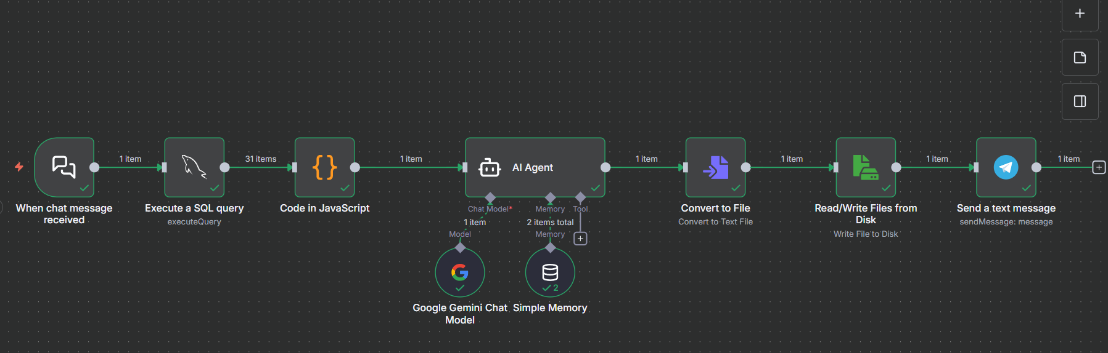

**Workflow Components**

**1. When chat message received (Chat Trigger)**

* **Type:** @n8n/n8n-nodes.chatTrigger
* **Purpose:** Entry point for the workflow that provides a chat interface
* **Configuration:** 
  + **Initial Message:** "Hi there! 👋 I am a data analyst assistant how can I help u?"
  + **Input Placeholder:** "Type your question.."
  + **Title:** "Your first insight"
  + **Public Access:** Enabled
  + **Webhook ID:** b0ce7bae-d281-4ba4-9b3c-bcf30b23c74a

**What it does: Creates a web-based chat interface where users can interact with the AI agent. When a user sends a message, it triggers the entire workflow.**

**2. Execute a SQL query (MySQL Node)**

* **Type:** n8n-nodes-base.mySql
* **Purpose:** Retrieves cricket batsmen data from the database
* **Configuration:** 
  + Operation: Execute Query
  + Query: SELECT * FROM cricket_batsmen;
  + Credentials: MySQL account (ID: BeitVCUr1wQHig4G)

**What it does: Connects to the MySQL database and retrieves all records from the cricket_batsmen table. The table contains columns like:**

* Batsmen (player name)
* Run_Score (runs scored)
* Strike_Rate (batting strike rate)
* Team (player's team)
* Opposition (opponent team)
* Venue (match location)

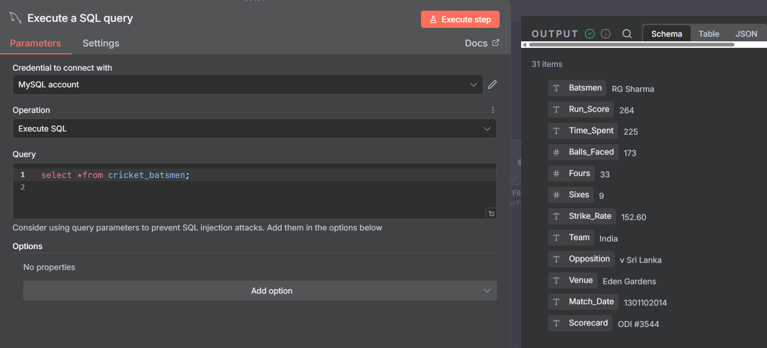

**3. Code in JavaScript (Data Transformation)**

* **Type:** n8n-nodes-base.code
* **Purpose:** Transforms raw SQL data into a structured prompt for the AI
* **Key Functions:**

**javascript**

*// Collects all SQL query results*

const rows = $input.all().map(item => item.json);

*// Builds human-readable summary*

dataSummary += `${r.Batsmen} scored ${r.Run_Score} runs

with a strike rate of ${r.Strike_Rate}

for ${r.Team} vs ${r.Opposition} at ${r.Venue}.\n`;

*// Creates analysis prompt for AI*

const prompt = dataSummary + analysis_instructions;

```

**What it does:**

1. Receives all rows from the SQL query

2. Formats each record into a readable sentence

3. Constructs a detailed prompt asking Gemini to:

- Identify top 3 batsmen with highest strike rates

- Provide numerical strike rate values

- Compare their performance (aggression, consistency, etc.)

4. Outputs the formatted prompt as JSON

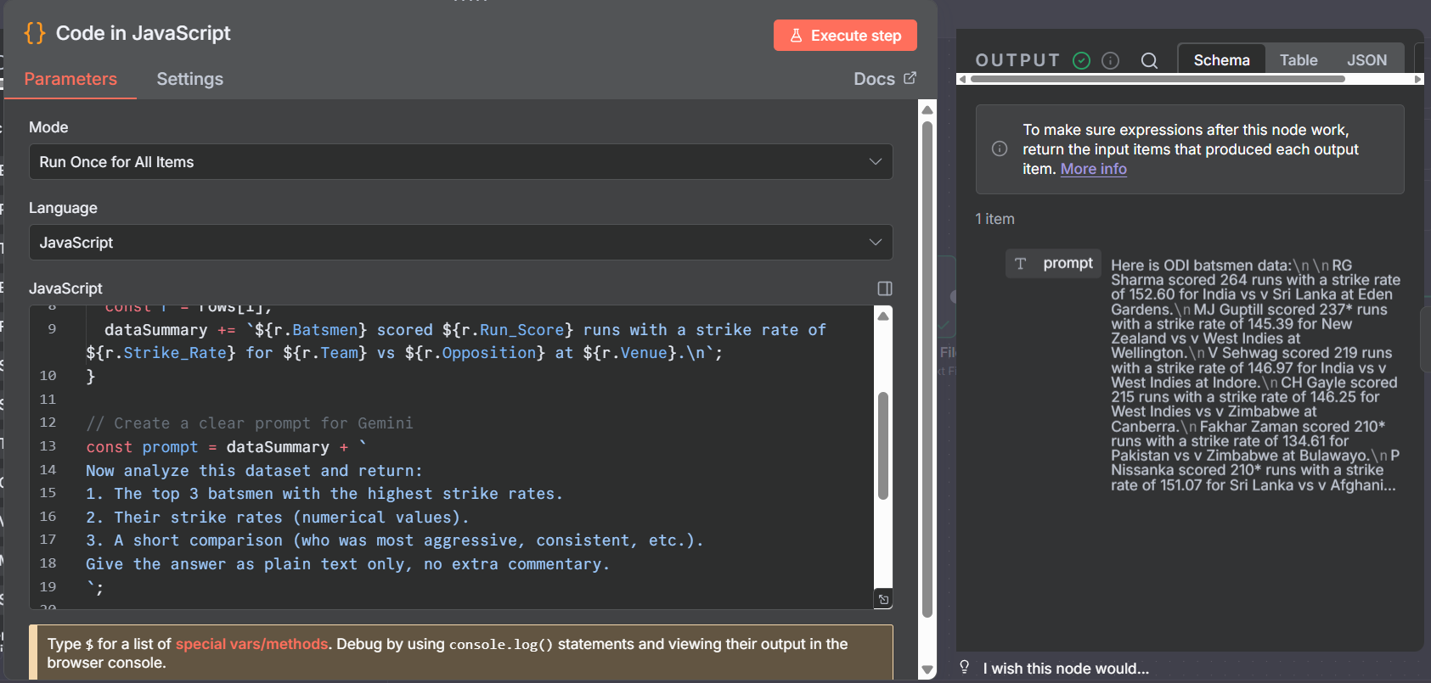

**4. AI Agent**

**Type:**@n8n/n8n-nodes.agent

**Purpose:** Orchestrates the AI analysis using Google Gemini

**System Message:**

```

You are an n8n Data Analyst AI Agent, a friendly and approachable

expert on the n8n platform. You help users load, inspect, and

manipulate spreadsheet or CSV data...

```

**Configuration:**

**Prompt Type:** Define

**Input: =**{{$json["prompt"]}}

**What it does: Acts as the brain of the workflow, processing the data prompt and generating intelligent analysis using the connected AI model and memory.**

**5. Google Gemini Chat Model (LLM)**

**Type**:@n8n/n8n-nodes.lmChatGoogleGemini

**Purpose:** Provides AI language processing capabilities

**Credentials:** Google Gemini (PaLM) API account (ID: RML2cd0VK3iQHYrh)

**What it does: Connected to the AI Agent node, this provides the actual AI processing power using Google's Gemini model to analyze the cricket statistics and generate insights.**

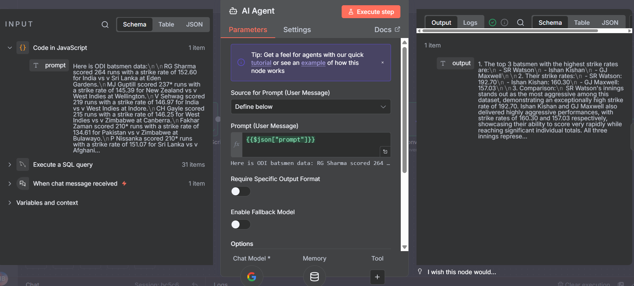

**6. Simple Memory (Memory Buffer)**

**Type**:@n8n/n8n-nodes.memoryBufferWindow

**Purpose:** Maintains conversation context

**Configuration:**

**Context Window Length:** 15 messages

**What it does: Stores the last 15 messages in the conversation, allowing the AI to remember previous questions and answers for more contextual responses.**

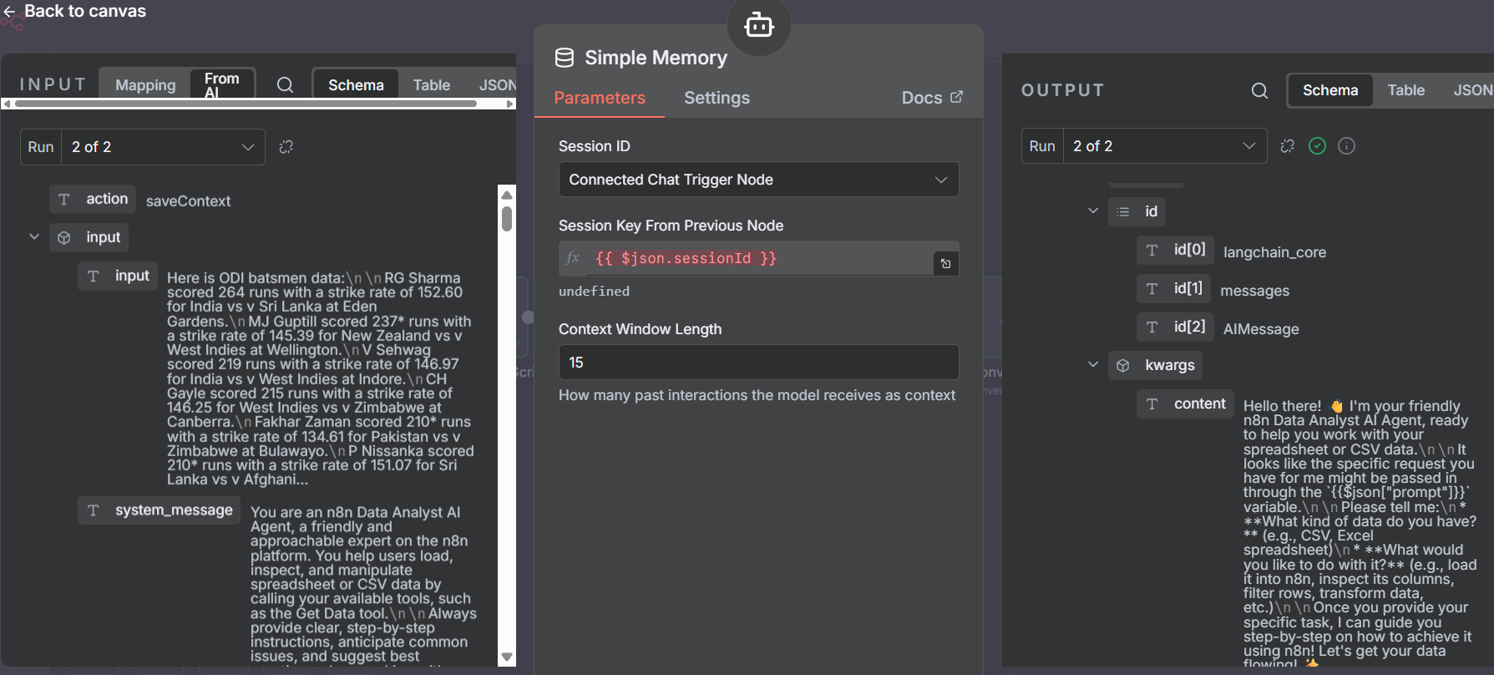

**7. Convert to File (File Conversion)**

**Type:** n8n-nodes-base.convertToFile

**Purpose:** Converts AI response text to a file format

**Configuration:**

**Operation:** To Text

**Source Property:**={{$json["text"]}}

**What it does: Takes the AI-generated analysis (text format) and converts it into a file object that can be saved to disk.**

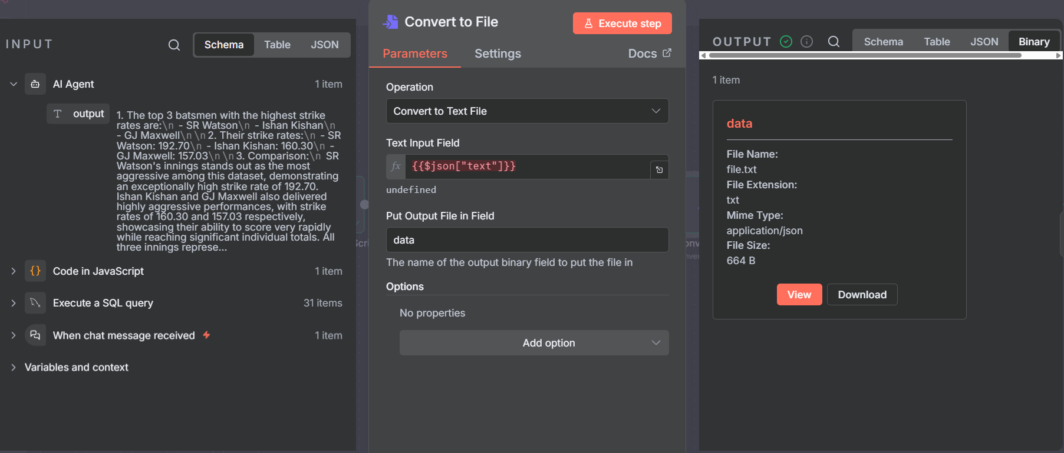

**8. Read/Write Files from Disk (File Storage)**

**Type:** n8n-nodes-base.readWriteFile

**Purpose:** Saves the AI analysis to the server filesystem

**Configuration:**

**Operation:**Write

**File Name:/home/node/files/ai_output.txt**

**What it does:Writes the AI-generated analysis to a text file on the n8n server at the specified path.**

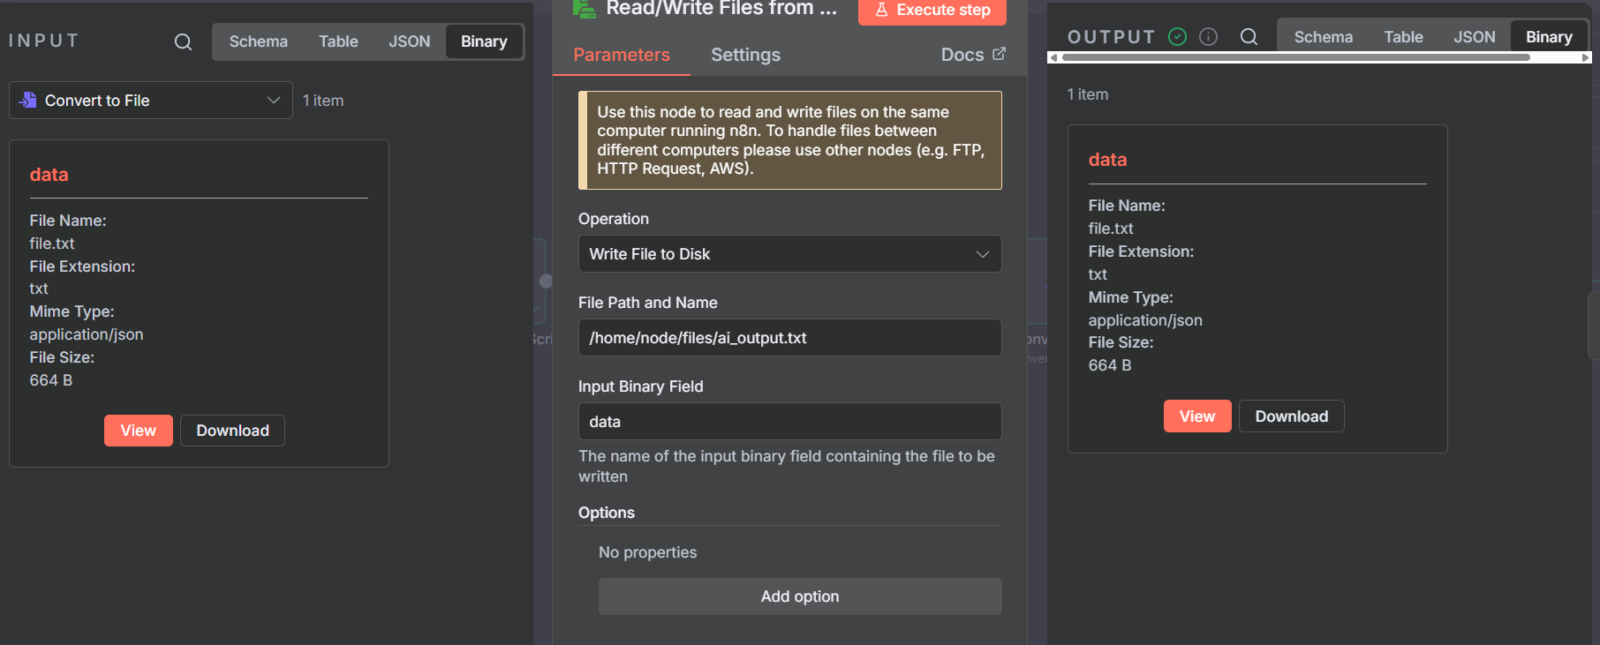

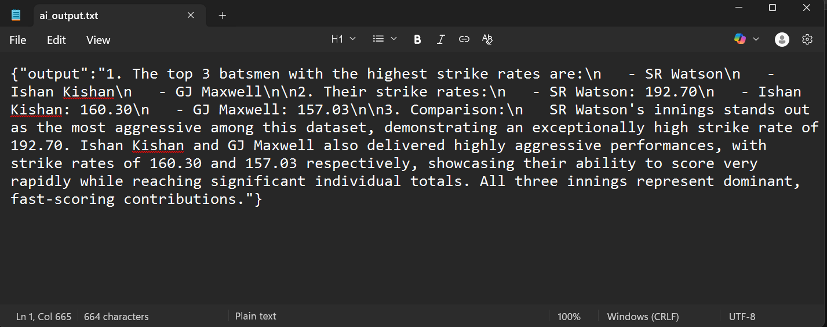

**9. Send a text message (Telegram Notification)**

**Type:**n8n-nodes-base.telegram

**Purpose:** Sends notification when analysis is complete

**Configuration:**

**Chat ID:** 6356198890

**Message**:"The AI output file has been created at C:/n8n_files/ai_output.txt"

**What it does: Sends a Telegram message to the specified chat ID informing the user that their analysis file is ready.**

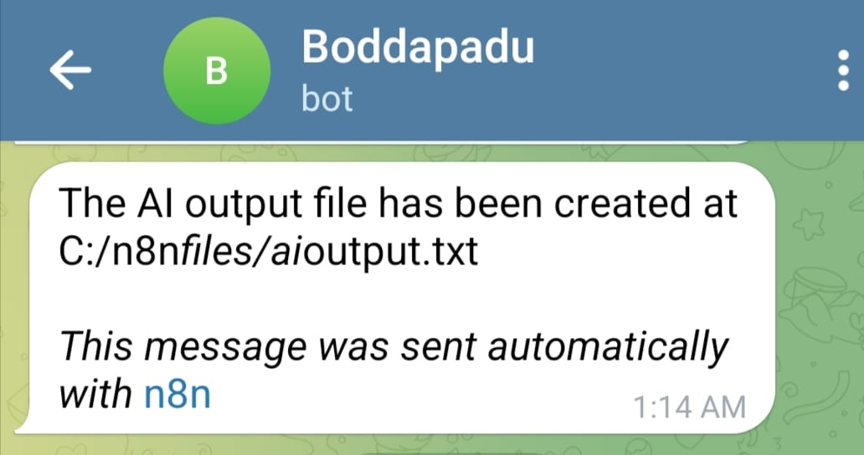

**Data Flow Diagram**

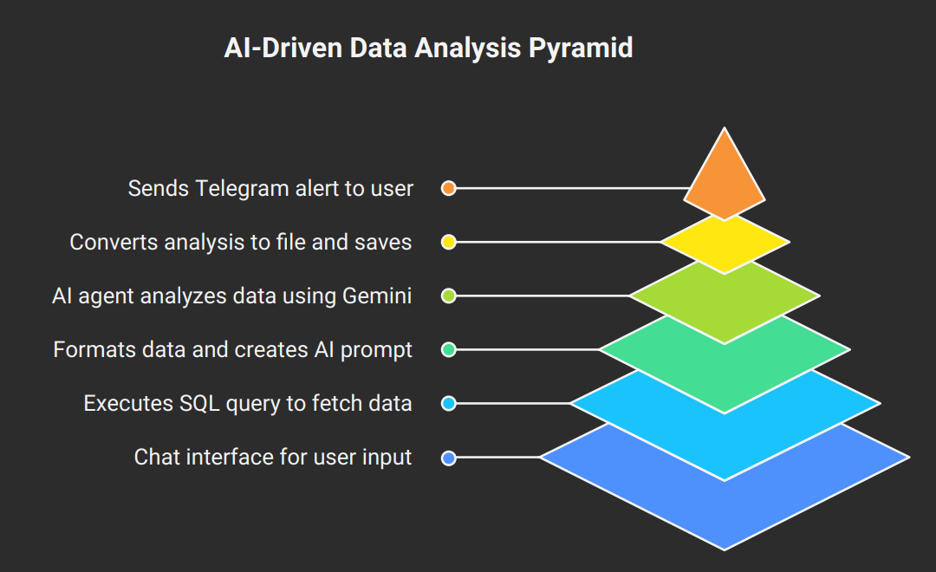

**Step-by-Step Execution Flow**

**Step 1: User Initiates Chat**

1. User opens the chat interface (webhook URL)
2. Sees welcome message: "Hi there! 👋 I am a data analyst assistant how can I help u?"
3. Types a question about cricket statistics

**Step 2: Data Retrieval**

1. Chat trigger activates the workflow
2. MySQL node executes: SELECT * FROM cricket_batsmen;
3. All batsmen records are retrieved from the database

**Step 3: Data Transformation**

1. JavaScript Code node receives SQL results
2. Iterates through each record
3. Formats data into readable sentences
4. Creates a comprehensive prompt requesting:
   * Top 3 batsmen by strike rate
   * Their numerical strike rates
   * Performance comparison

**Step 4: AI Analysis**

1. AI Agent receives the formatted prompt
2. Google Gemini processes the data
3. Simple Memory provides conversation context
4. AI generates detailed analysis with insights

**Step 5: File Creation**

1. Convert to File node transforms AI text to file format
2. Read/Write Files node saves to: /home/node/files/ai_output.txt

**Step 6: Notification**

1. Telegram node sends message to chat ID: 6356198890
2. Message confirms file creation at: C:/n8n_files/ai_output.txt

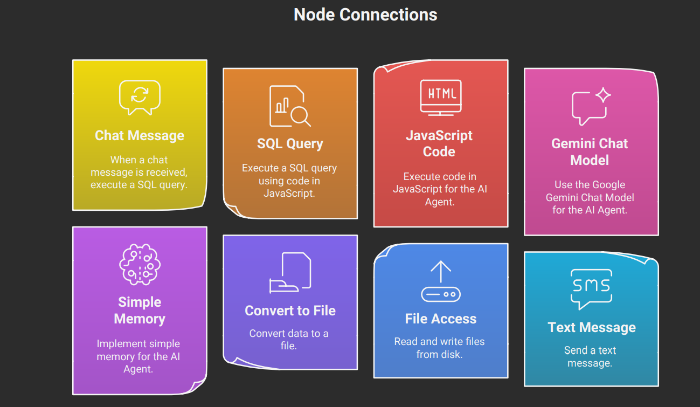

**Key Features**

**🤖 AI-Powered Analysis**

* Uses Google Gemini for intelligent data interpretation
* Provides comparative analysis and insights

**💾 Conversation Memory**

* Remembers last 15 messages
* Enables contextual follow-up questions

**📊 Database Integration**

* Direct SQL query execution
* Real-time data retrieval

**📁 File Output**

* Saves analysis to persistent storage
* Creates timestamped records of insights

**📱 Telegram Notifications**

* Instant alerts when analysis completes
* Remote access to workflow status

**Configuration Requirements**

**Required Credentials**

1. **MySQL Database** 
   * Host, port, database name
   * Username and password
   * Table: cricket_batsmen
2. **Google Gemini API** 
   * API key from Google AI Studio
   * Access to Gemini model
3. **Telegram Bot** 
   * Bot token from @BotFather
   * Chat ID for notifications

**System Requirements**

* n8n instance (self-hosted or cloud)
* File system access: /home/node/files/
* Network access to MySQL server
* Internet connectivity for API calls

**Future Enhancements**

* Add support for multiple database tables
* Implement data visualization (charts/graphs)
* Add export to PDF/Excel functionality
* Create scheduled analysis reports
* Implement user authentication
* Add support for natural language SQL queries

**Conclusion**

This workflow demonstrates a powerful integration of database querying, AI analysis, and automated notifications. It transforms raw cricket statistics into actionable insights through conversational AI, making data analysis accessible to users without technical expertise.